

**UE22CS352B - Object Oriented Analysis & Design**

Mini Project Report

Title: Restaurant booking system

***Submitted by:***

***Name : SRN (Team Members)***

|  |  |
| --- | --- |
| **NARU MEGHANA**  **NEHA GIRISH**  **NIDA FATHIMA NIKHITA G** | **PES2UG22CS341**  **PES2UG22CS346**  **PES2UG22CS353**  **PES2UG22CS359** |

Semester - 6 Section - F

# Facultly Name : Divya Ebenezer

**January - May 2025**

##### DEPARTMENT OF COMPUTER SCIENCE AND ENGINEERING

FACULTY OF ENGINEERING

##### PES UNIVERSITY

(Established under Karnataka Act No. 16 of 2013) 100ft Ring Road, Bengaluru – 560 085, Karnataka, India

##### Problem Statement:

##### Managing reservations in a restaurant is a common operational challenge. Customers need a seamless way to check availability and reserve tables, while restaurant administrators require tools to manage and view bookings efficiently. Manual systems often lead to overbooking, errors in scheduling, and lack of visibility for both customers and staff.

##### This project aims to develop a web-based restaurant table booking system that allows customers to book tables by specifying their desired time slots and enables administrators to view, manage, and update reservations in real time. The system ensures fair allocation of tables, avoids double bookings, and keeps all data consistent using a backend service and database integration.

**Key Features:**

* **Customer-Side Features:**
  + **Table Booking Interface**: Customers can view available tables and reserve them for a selected date and time range.
  + **Availability Validation**: System checks for overlapping time slots before confirming bookings to prevent conflicts.
  + **Booking Duration Enforcement**: Validates that reservations follow a minimum of 30 minutes and a maximum of 3 hours
  + **Delete Reservations**: Users can remove any reservation through the frontend using their name, date, arrival time, and table id, updating both the in-memory system and the database.
* **Admin Features:**
  + **Admin Panel for Reservation Overview**: Allows administrators to view all reservations with details like customer name, date, time, and table size.
  + **Search Functionality**: Admins can filter reservations based on customer names.
* **Backend Features:**
  + **Spring Boot REST API**: Handles all table and reservation operations with clearly defined endpoints.
  + **In-Memory + MongoDB Integration**: All data is managed in memory during runtime and synced with MongoDB for persistence.
  + **Factory Pattern for Table Creation**: Supports dynamic creation of different types of tables based on size.
  + **Validation Logic**: Prevents booking of already reserved tables and validates time slots with informative UI feedback.
* **Design Highlights:**
  + Follows **MVC architecture** with clear separation of concerns.
  + Uses **design patterns** such as Singleton, Factory, Adapter, and Command to ensure modularity and scalability.
  + Built with **Java Spring Boot**, **HTML/CSS/JS frontend**, and **MongoDB** for storage.

## Models:

**Use Case Diagram:**

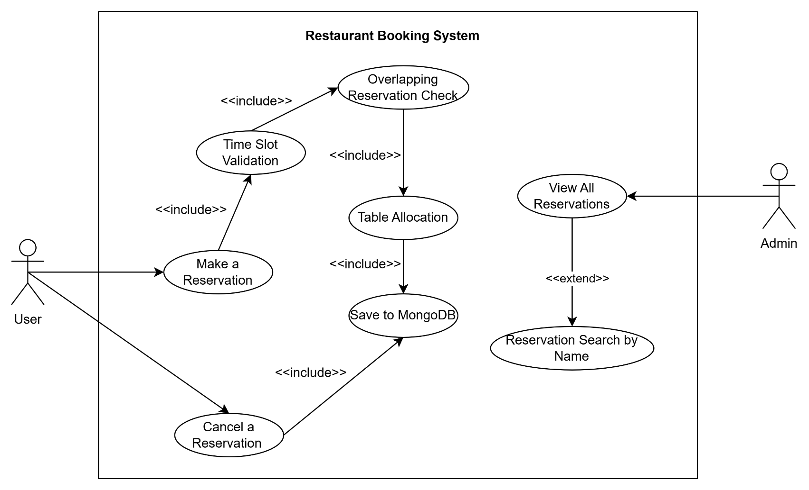

**Class Diagram:**

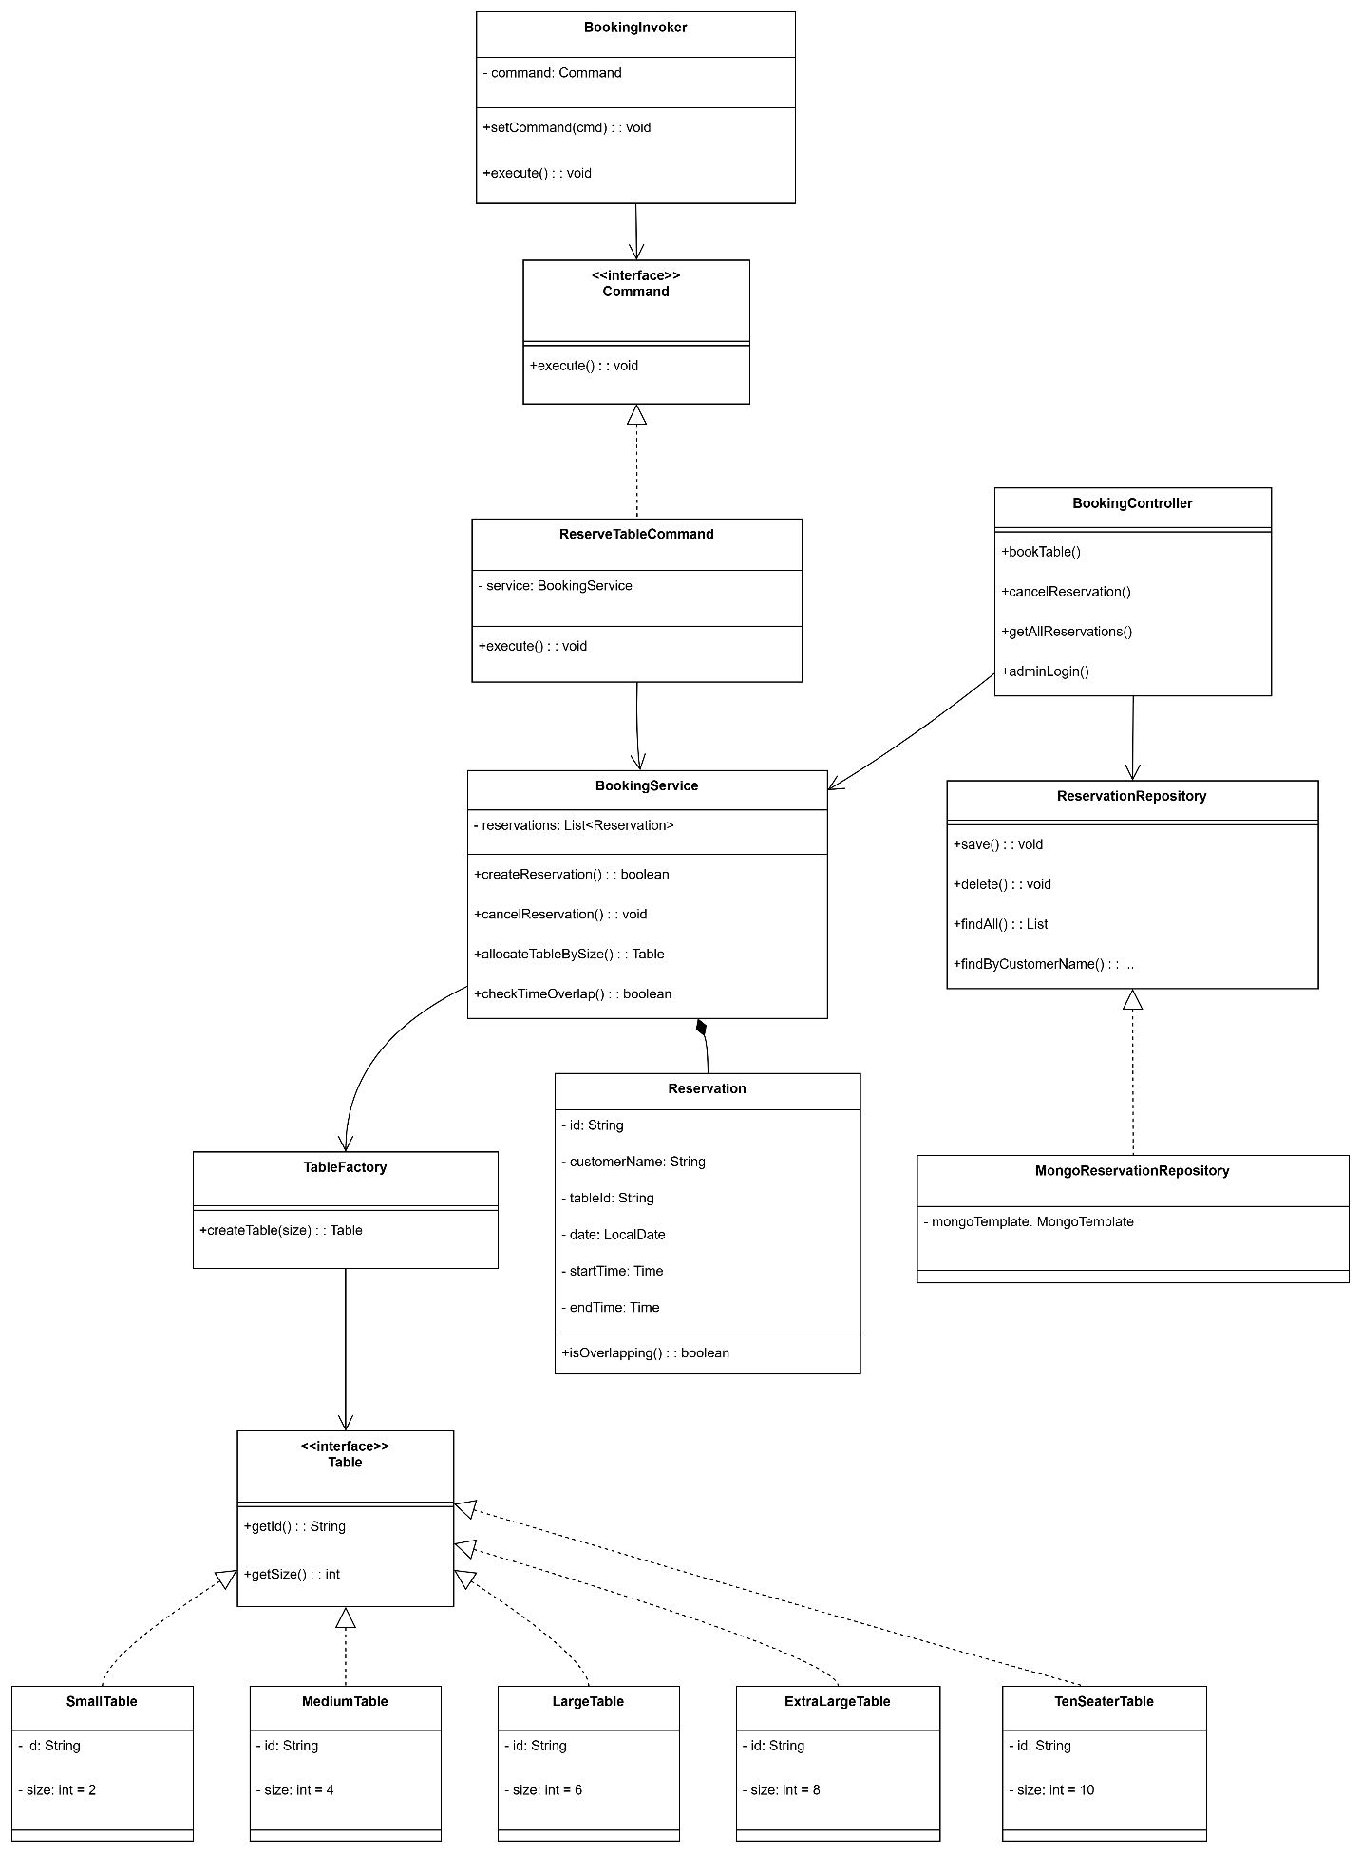

# State Diagram:

# 

**Activity Diagrams:**

1. Major Usecase

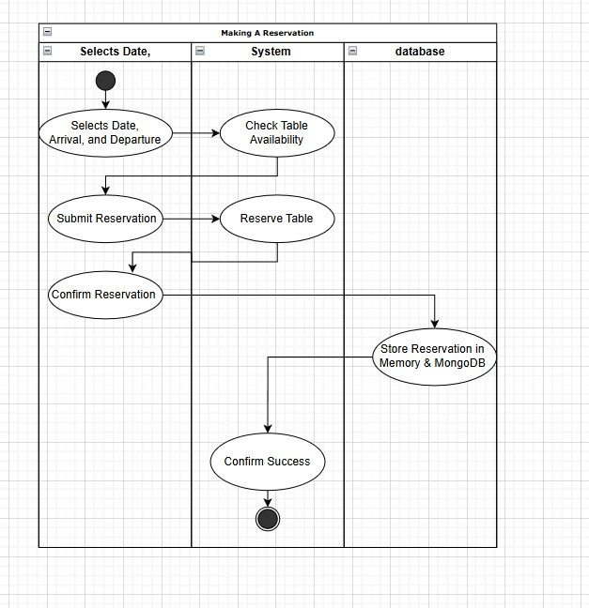

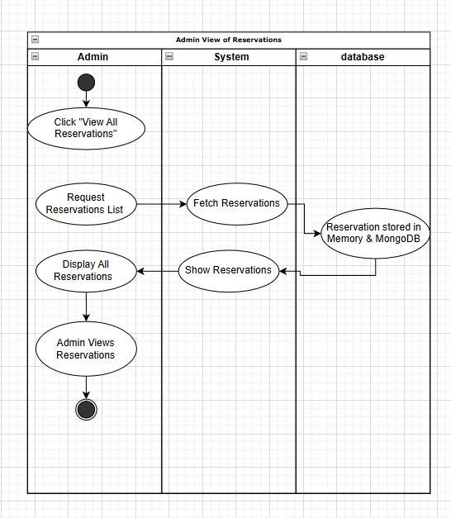

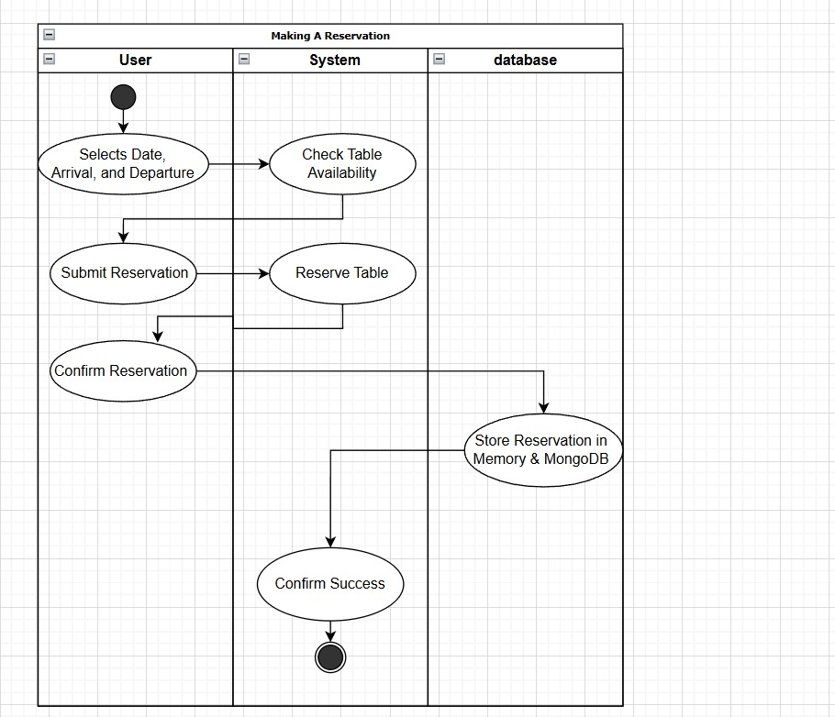

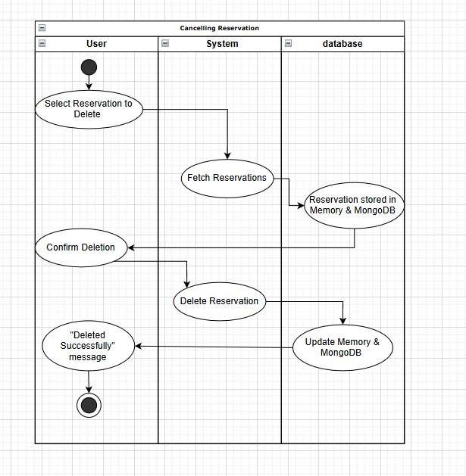

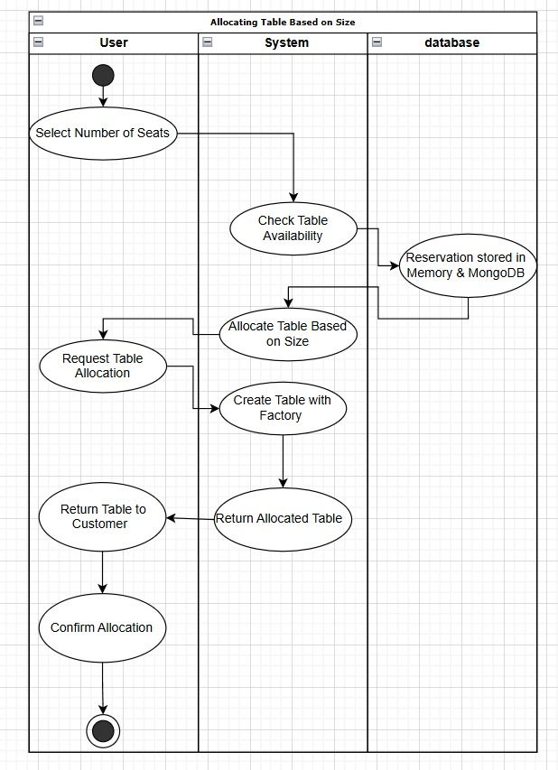

1. Minor Use case

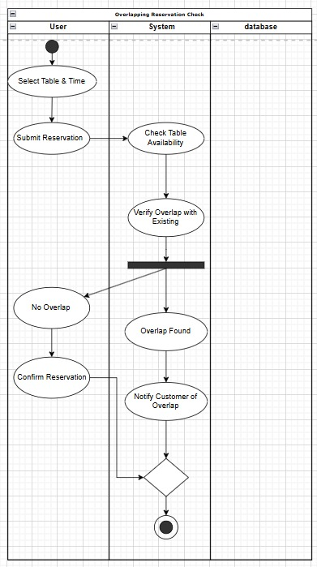

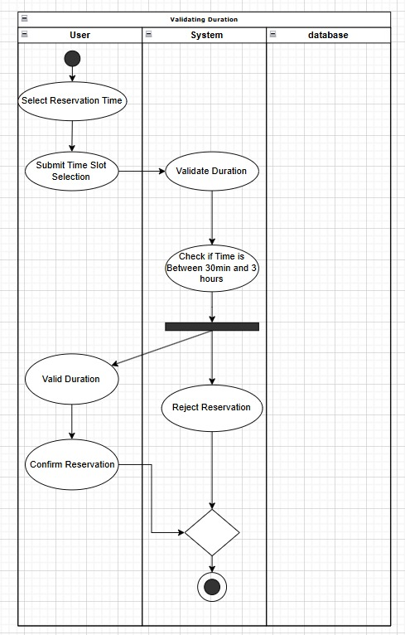

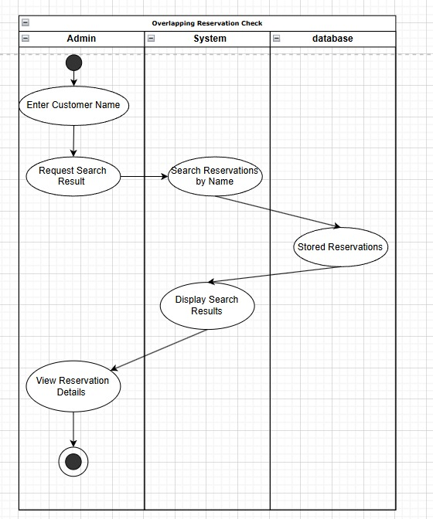

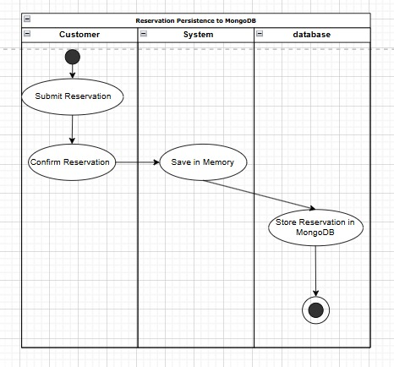

Architecture Patterns, Design Principles, and Design Patterns:

# Architecture Patterns

# Model – View – Controller Pattern (MVC)

# MVC Architecture in Your Restaurant Booking System

# The Model-View-Controller (MVC) architecture is clearly reflected in the directory and class structure of your Spring Boot application. This architecture separates the application into three core responsibilities: Model (Data and Business Logic), View (User Interface), and Controller (Request Handling & Routing).

# Model

# Role: Contains the data structure, business logic, and database interaction logic.

# Folder: backend/src/main/java/com/restaurant/booking/model

# Classes:

# Reservation, ReservationDocument – store booking data.

# Table, SmallTable, MediumTable, etc. – different types of restaurant tables.

# TableFactory – applies the Factory Pattern to create tables.

# ReserveTableCommand, Command – used for encapsulating actions (Command Pattern).

# Database Integration:

# ReservationDocument maps data to MongoDB.

# ReservationRepository in repository/ handles persistence.

# These classes define and manage the application’s core entities, their relationships, and behavior.

# View

# Role: Defines how data is presented to users and how they interact with the system.

# Folder: frontend/

# Files:

# index.html: Customer interface for booking tables.

# admin.html: Admin panel to view and manage reservations.

# login.html: (Optional) for authentication or future enhancements.

# Interactivity:

# JavaScript sends AJAX requests to your backend endpoints to dynamically update table availability, show errors, and delete reservations.

# The View makes API calls to the Controller and updates the UI based on responses (e.g., booking success, unavailable tables).

# Controller

# Role: Acts as the middleman between the View and the Model. It handles HTTP requests, performs logic via the Service, and returns responses.

# Folder: backend/src/main/java/com/restaurant/booking/controller

# Class: BookingController.java

# Maps frontend requests (/api/reservations, /api/deleteReservation, etc.).

# Delegates tasks to BookingService in the service/ package.

# Returns JSON responses for frontend rendering.

# The Controller handles communication between the UI and the underlying system logic.

# Service Layer

# Although not part of classic MVC, the Service Layer in Spring projects contains core business logic separate from both the Controller and the Model.

# Folder: backend/src/main/java/com/restaurant/booking/service

# Class: BookingService.java

# Contains the logic to:

# Check for table availability.

# Detect time overlaps.

# Save and retrieve reservations.

# Annotated with @Service, making it a Singleton.

# This helps maintain cleaner controllers and promotes separation of concerns.

# Design Principles

### Design Principles Implemented in the Project

* **Single Responsibility Principle (SRP)**
  + Each class in the project is focused on a single responsibility.
  + Examples:
    - BookingService handles business logic related to booking.
    - BookingController manages HTTP requests and user interaction.
    - ReservationRepository is responsible for MongoDB operations.
* **Open/Closed Principle (OCP)**
  + Classes are open for extension but closed for modification.
  + Example:
    - You can add new types of tables (ExtraLargeTable, TenSeaterTable, etc.) without changing the existing logic in TableFactory.
* **Liskov Substitution Principle (LSP)**
  + Subclasses can be used wherever their parent classes are used without affecting the program’s correctness.
  + Example:
    - All Table subclasses (SmallTable, MediumTable, etc.) can be used interchangeably in reservation logic.
* **Interface Segregation Principle (ISP)**
  + Interfaces are kept small and relevant to specific needs.
  + Example:
    - The Command interface defines only what is necessary for command actions, avoiding bloated interfaces.
* **Dependency Inversion Principle (DIP)**
  + High-level modules do not depend on low-level modules directly; both depend on abstractions.
  + Example:
    - BookingService depends on the ReservationRepository interface, not the MongoDB implementation, allowing for easier testing and flexibility.

### GRASP Principles Reflected in the Project

* **Controller**
  + The BookingController acts as the controller handling user actions and HTTP endpoints.
* **Creator**
  + BookingService creates reservation instances and assigns them as needed.
* **Information Expert**
  + Classes like TableFactory and Reservation contain and operate on their own data, making them experts of their own state.
* **Low Coupling**
  + Each layer (controller, service, model, repository) interacts through well-defined interfaces, minimizing interdependencies.
* **High Cohesion**
  + Each class or component is tightly focused on one task (e.g., table creation, reservation processing), improving maintainability.

# Design Patterns

|  |  |  |  |
| --- | --- | --- | --- |
| **Pattern** | **Type** | **Where It’s Used** | **Why It’s Used** |
| Singleton | Creational | @Service-annotated BookingService class | Ensures only one instance exists and is reused throughout the application lifecycle for consistent logic. |
| Factory | Creational | TableFactory class creates different types of tables (SmallTable, MediumTable, etc.) | Encapsulates object creation logic, simplifies table generation, and supports easy addition of new types. |
| Adapter | Structural | Converts ReservationDocument (MongoDB format) into internal Reservation model | Enables seamless integration between external data format (MongoDB) and internal logic by adapting structure. |
| Command | Behavioral | ReserveTableCommand and Command interface for reservation actions | Encapsulates actions like reserve, delete, and potentially update as command objects for better flexibility and potential undo/redo operations. |

### Github link to the Codebase:

# Screenshots

## UI:

## 

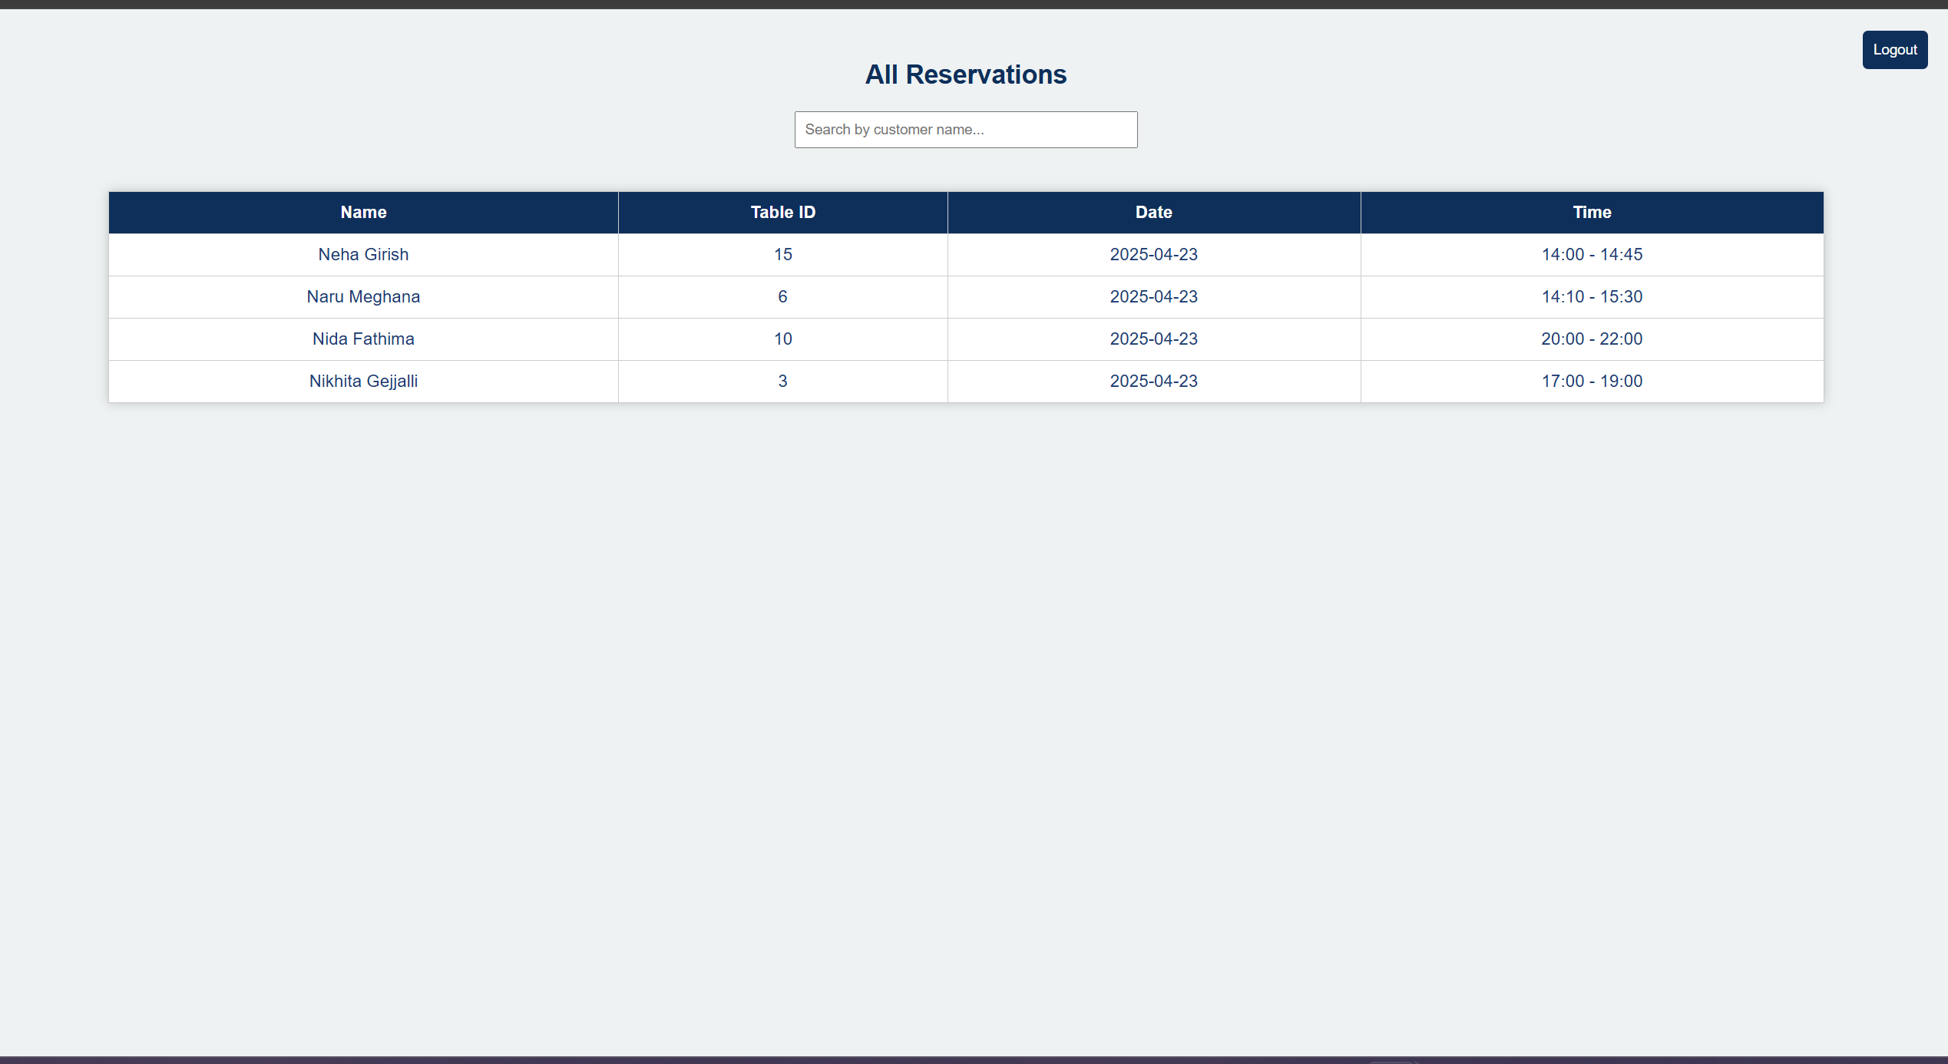

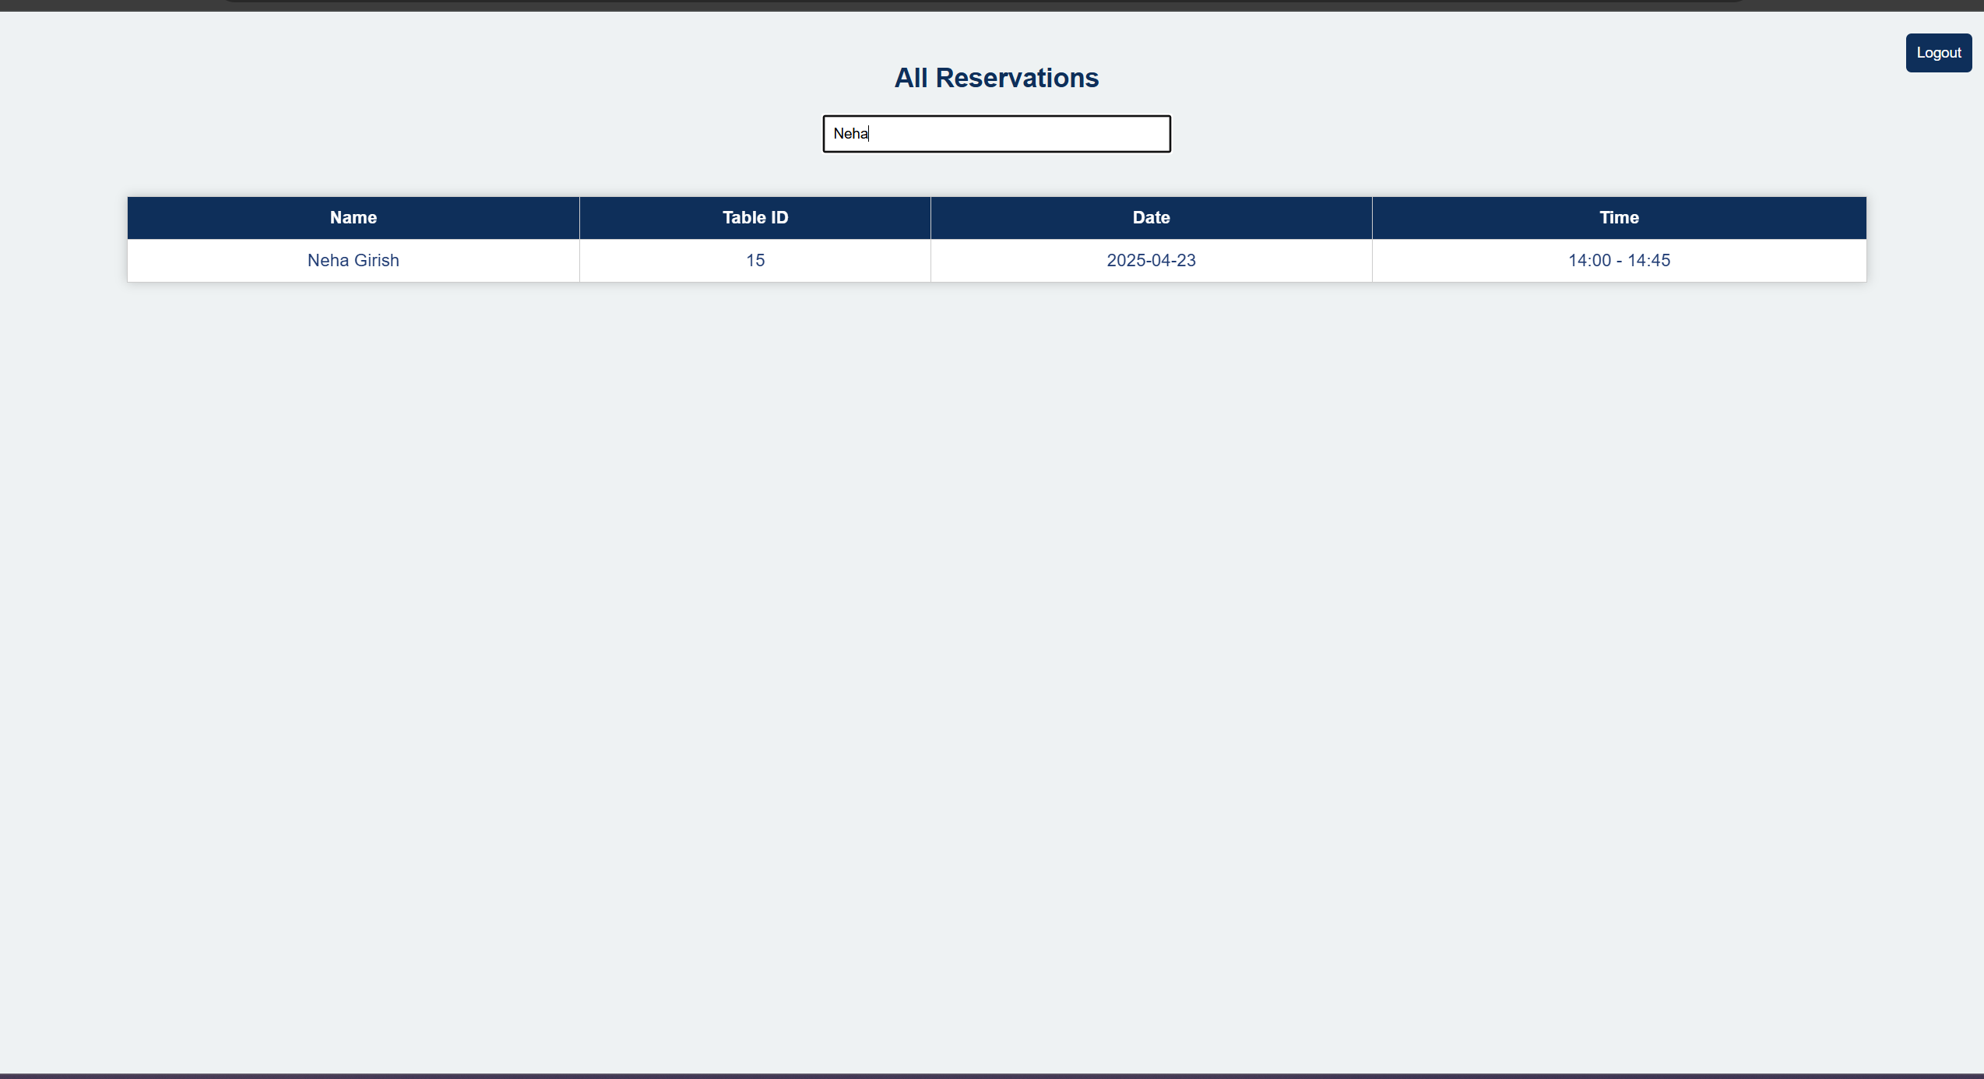

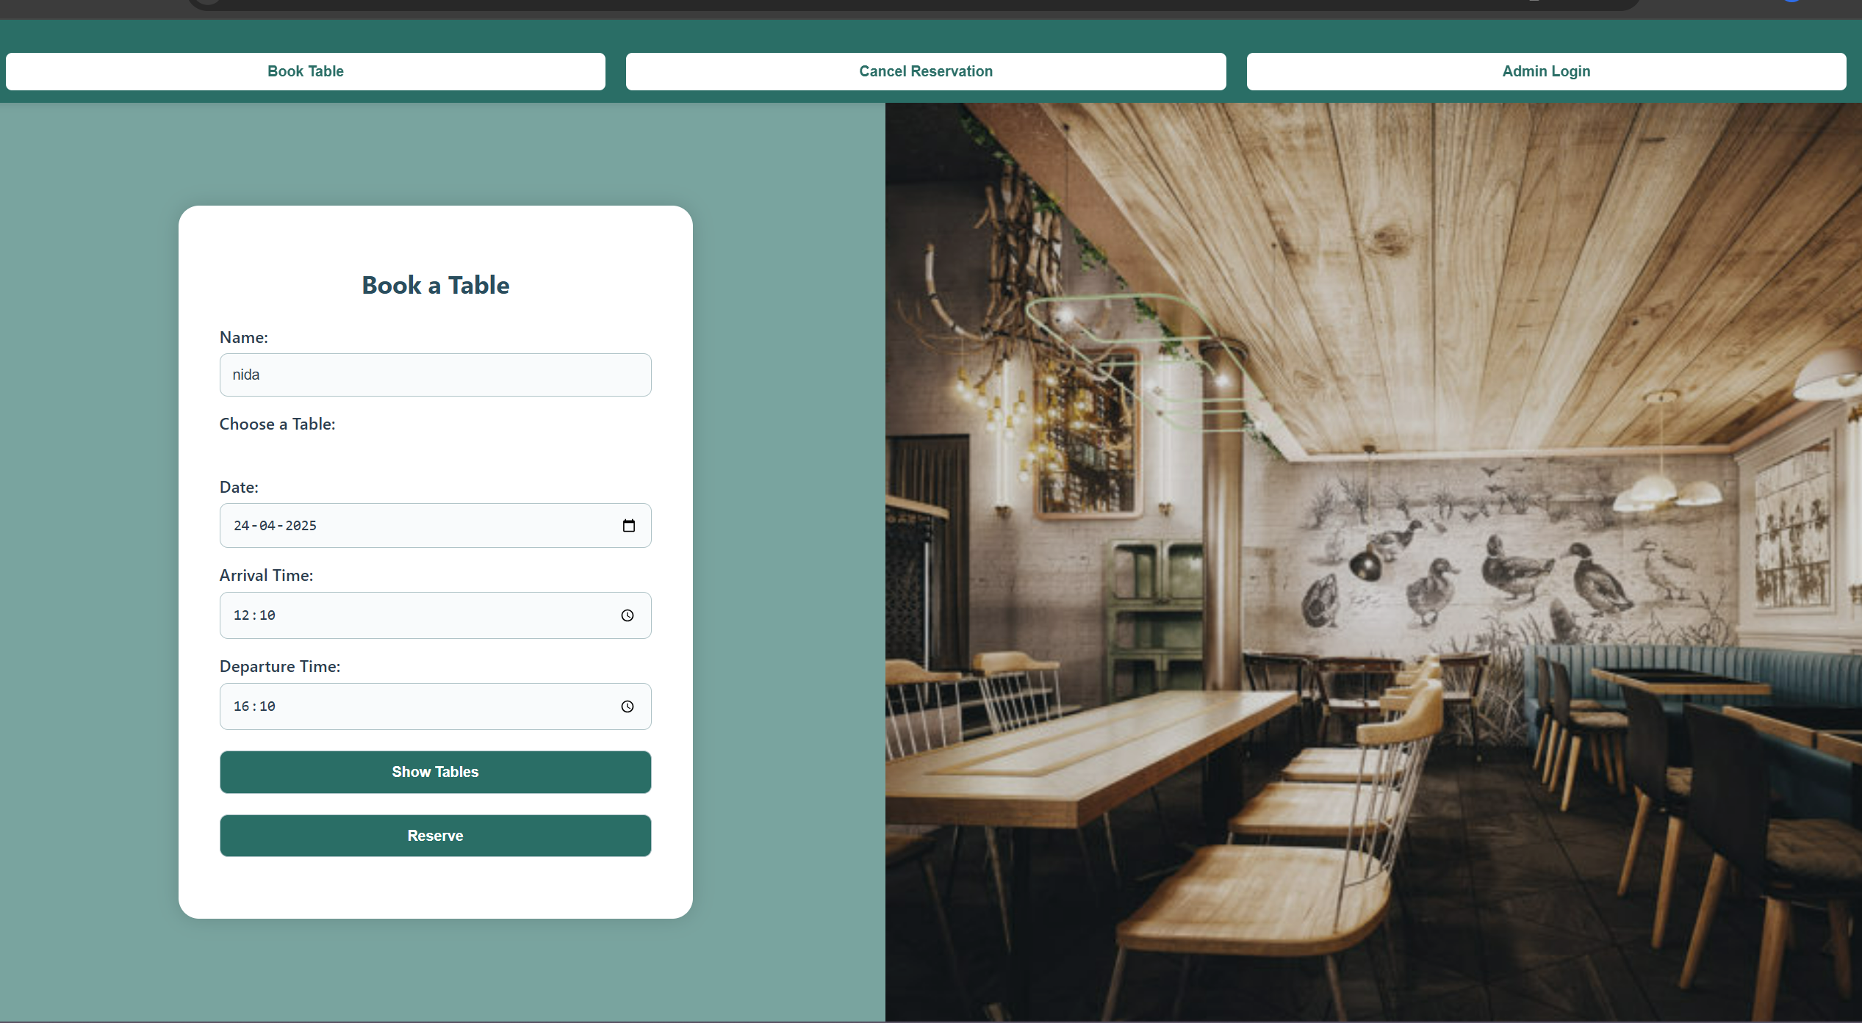

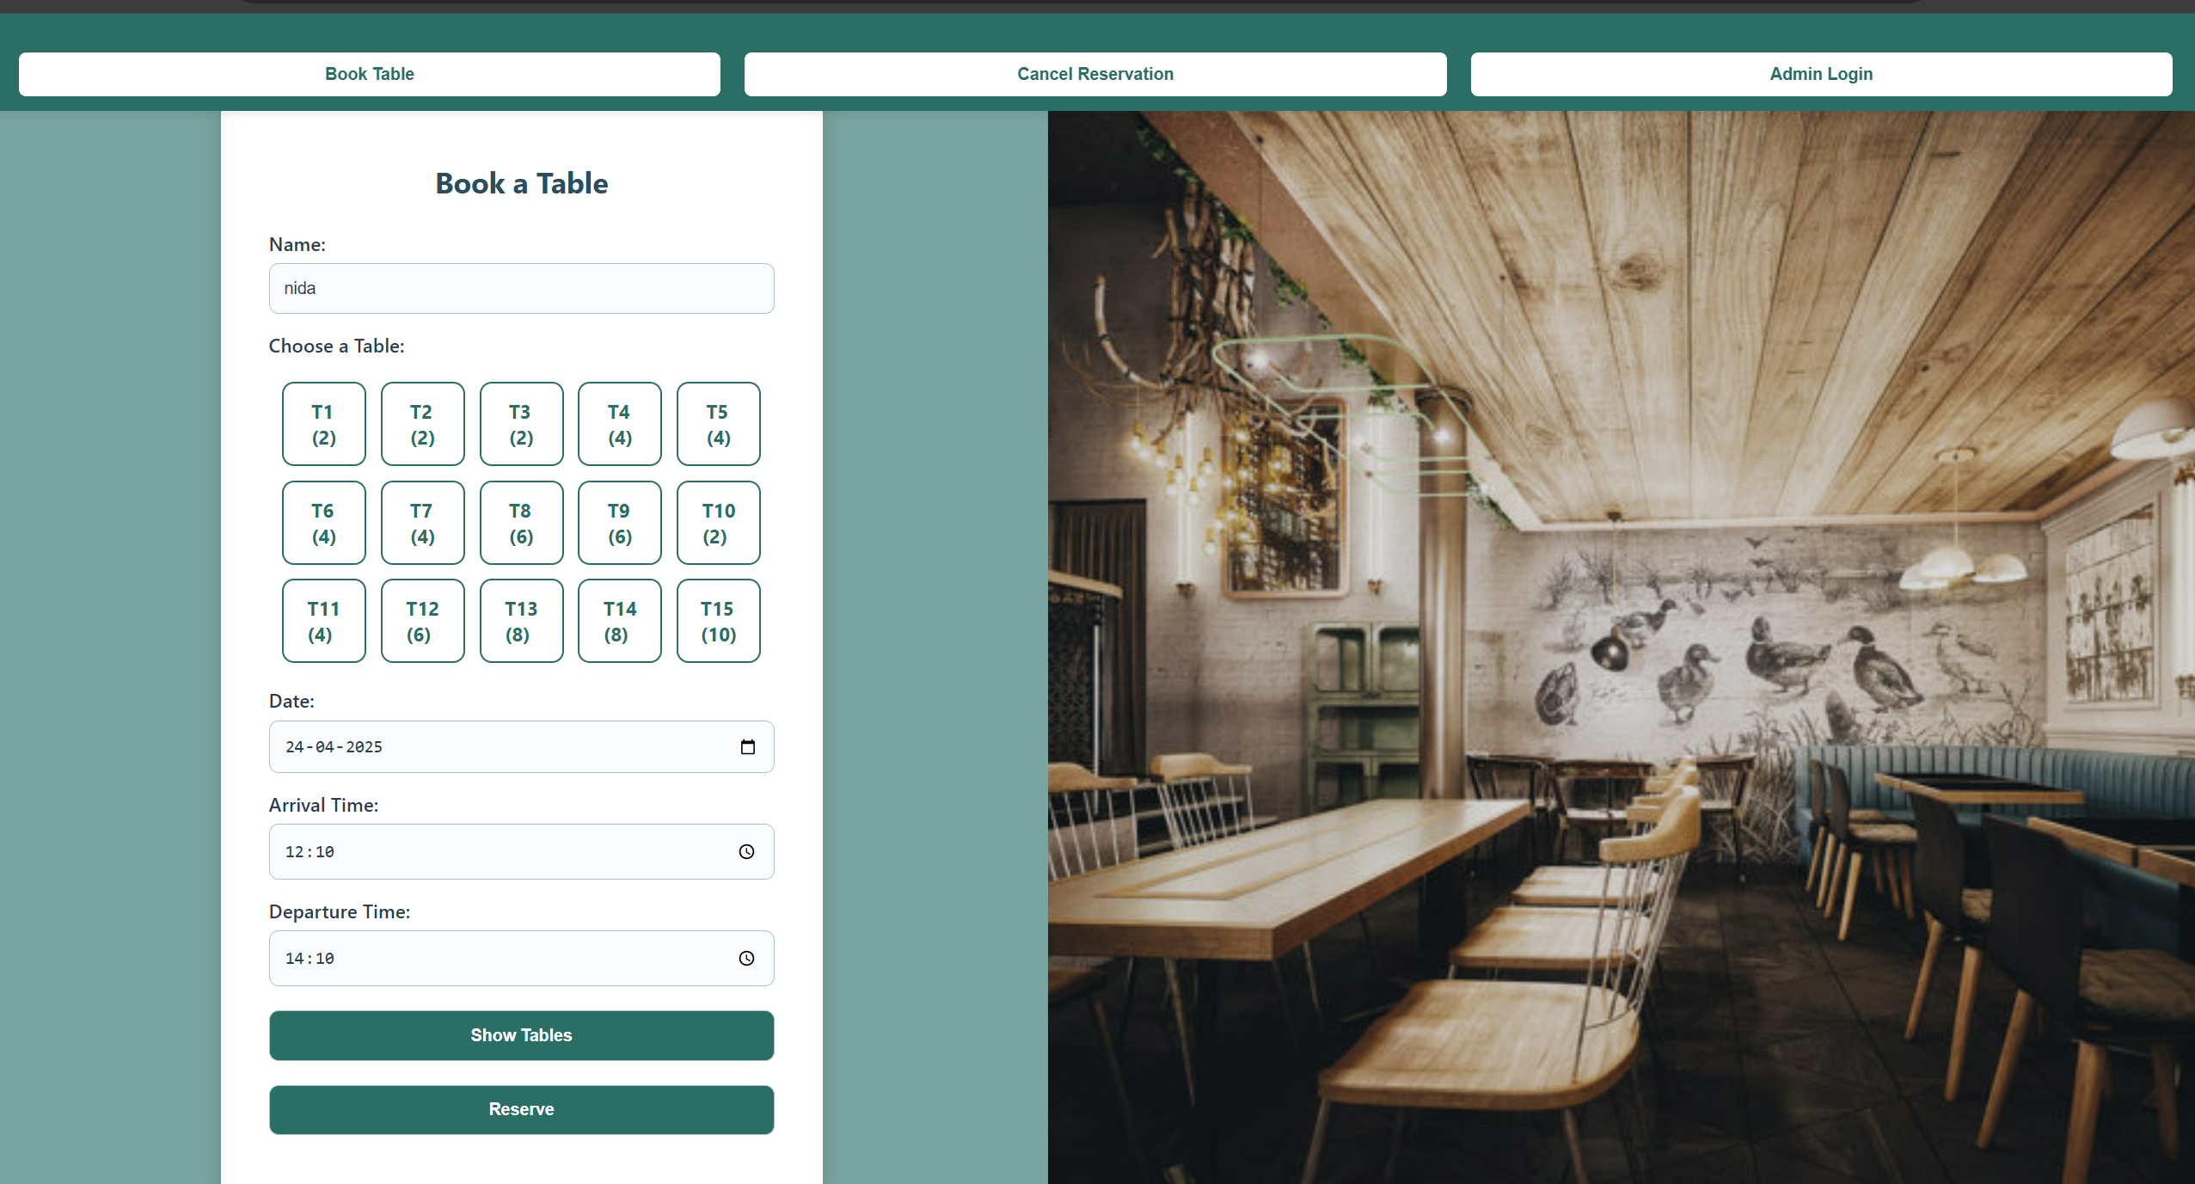

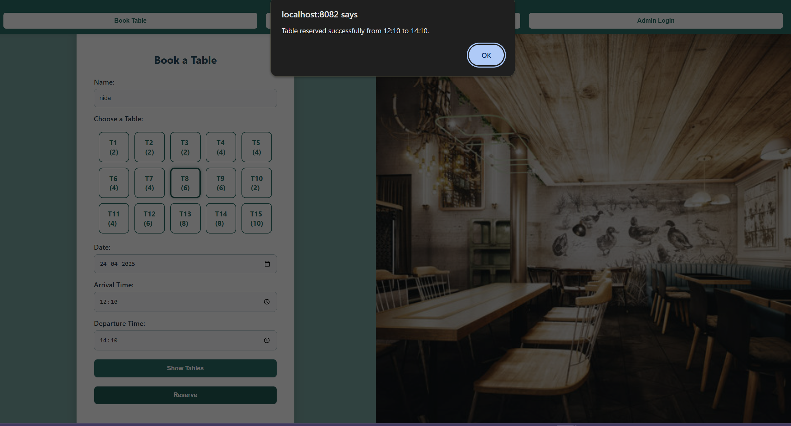

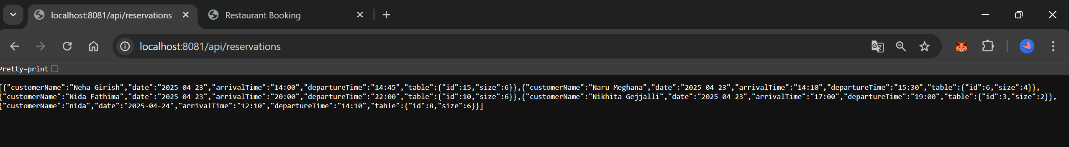

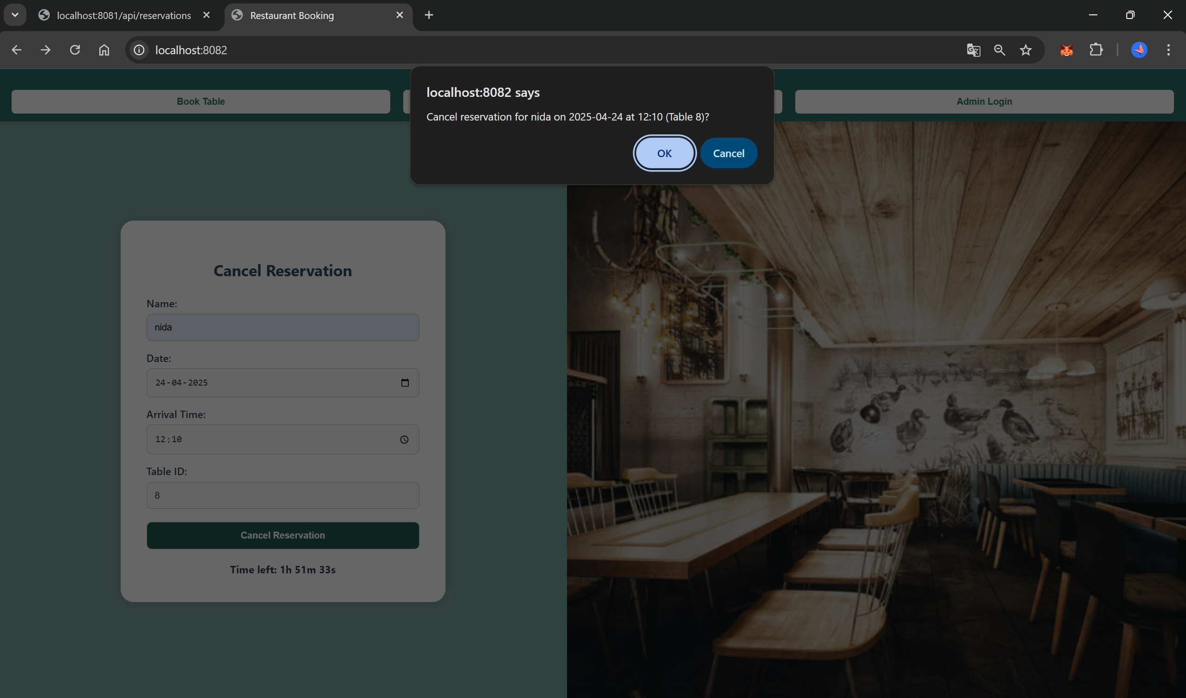

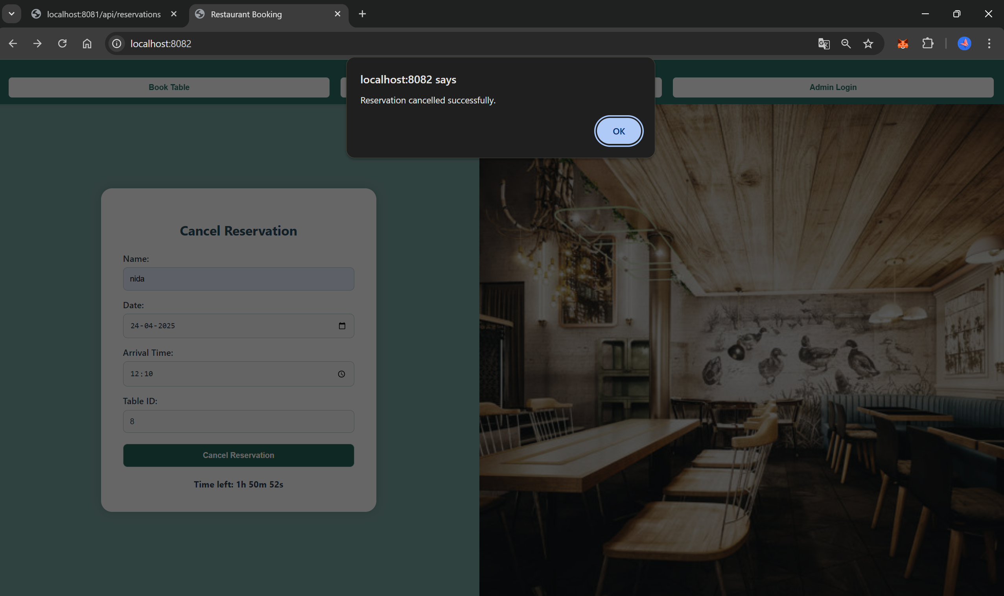

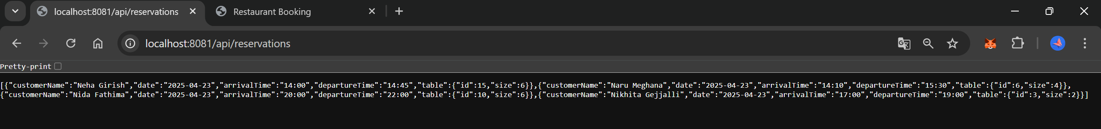

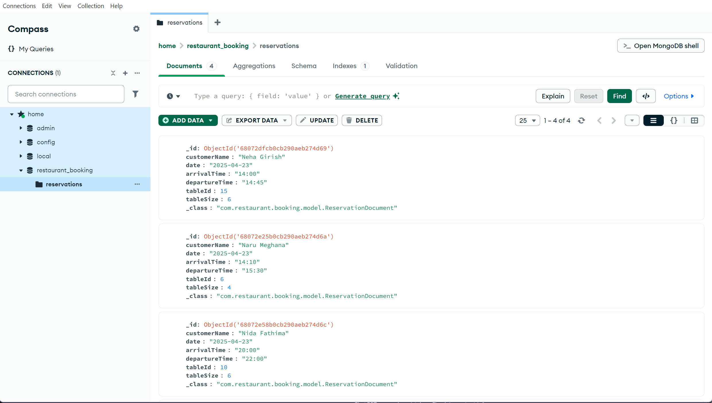

🡪Individual contributions of the team members:

|  |  |
| --- | --- |
| **Name** | **Module worked on** |
| **NARU MEGHANA** | * Implemented the **BookingService** layer with singleton scope. * Integrated business logic for reservations and table allocation. |
| **NEHA GIRISH** | * Implemented the **Command pattern** with Command, ReserveTableCommand, and BookingInvoker. * Assisted with controller logic and modular invocation structure. |
| **NIDA FATHIMA** | * Developed the **TableFactory** and different **Table** implementations. * Refactored to support flexible table creation via size-based logic. |
| **NIKHITA G** | * Designed MongoDB integration and implemented transformation logic(Adapter Pattern). * Worked on ReservationRepository and ReservationDocument handling. |